Use AI-assisted development with Accelerate Tech and Copilot in Power Platform

# Executive Summary

Accelerate Tech is a low-code system integrator and Microsoft partner. As Microsoft unveils Copilot experiences across product lines to assist business users and developers to achieve more with less in the AI era, companies need the expertise and guidance to seamlessly implement and adopt these solutions. Copilot implemented by a partner, like Accelerate Tech, can help developers of all skill levels build digital solutions more efficiently. Copilots help users navigate and act in those solutions. AI capabilities within the Power Platform leverage large language and artificial intelligence models that automate, simplify, and accelerate the development of digital solutions that are more intelligent and easier for development teams to build. It also brings increased intelligence to end-users so they can benefit from more robust solutions that are built with the same AI technology.

Low-code platforms such as Power Platform already enable tech-savvy business users to participate in creating digital business solutions. Copilot in Power Platform further democratizes this and simultaneously accelerates development in your IT department. Copilot in Power Platform is also available to users of Power Apps to assist them in getting the best use of the data in the apps that they use.

This whitepaper explores the available Copilots in Power Platform and how, when implemented by Accelerate Tech, they can revolutionize the creation of apps, web pages, workflows, and chatbots for your development teams and the users they build for.

Executive Summary 1

Introduction 3

Copilot for maker assist 7

Copilot for Power Apps 7

Copilot for Power Automate 8

Copilot for Power Pages 8

Copilot for Power Virtual Agents 9

Power Apps Copilot for users 10

Adding Copilot to low-code apps can make the applications more flexible to meet users' evolving needs. Instead of asking the maker to change the application, in many cases, users can simply ask the Copilot in the app the question about the data. 10

Power Platform connectors as Copilot plug-ins 11

Access Dataverse data in Microsoft 365 Copilot 11

Traditionally, users waste a fair amount of time jumping from one application to another to obtain the answers they need to complete a task. Imagine a user in Microsoft Outlook who just received an email from a client urgently asking for the status of their equipment being serviced. Currently, they leave their email client, open the internal application, look up the customer, open and copy the status of each piece of equipment, and then return to the email and type a summary of the equipment being serviced. Instead, the Microsoft 365 Copilot will be able to incorporate your Power Platform data stored in Microsoft Dataverse. Users can use application data without having to switch back and forth between applications. For example, from within the email client, a user could ask the Copilot to generate a status update for all the equipment being serviced for the client. Microsoft 365 Copilot automatically inherits the native security and governance framework of Dataverse and applies user security and permissions at runtime. 11

Embracing the next wave of AI Innovation 11

# Introduction

A new wave of AI innovation is underway across organizations as AI becomes more approachable and use cases become increasingly realizable. Before the current era of rapid innovation, AI functionality required dedicated data scientists to train and deploy for even basic AI scenarios. Almost overnight, that changed, and using large language models and generative AI enables organizations to innovate for a wide range of AI scenarios to drive efficiency.

Organizations relying only on traditional code-first developers need more resources, limiting their ability to build new AI solutions. This limitation can lead to lost opportunities and higher expenses, and in many cases, the creation of unnecessary technical debt that will require more long-term maintenance efforts than necessary. To help address this challenge, low-code integrators like Accelerate Tech can support global companies to seamlessly implement and train their teams on low-code capabilities in Microsoft Power Platform. Businesses can leverage the partner’s Microsoft expertise to extend Power Platform’s capabilities to empower users to apply AI to solve business problems, including normal business users with little or no formal training in traditional, code-first development.

Accelerate Tech stays up to date on Microsoft certifications, features, and capabilities as new Copilots are rolled out across product families to help businesses modernize by getting the most out of AI capabilities. The following are some of the top use cases we see our customers innovating with:

Organizations are now able to build proprietary solutions that include their own organization’s data and knowledge base being infused into these new AI experiences, giving them a competitive advantage over other organizations and generating benefits like cost and time savings, and the ability for developers to focus on more complex, high-value work. Accelerate Tech understands the importance of leveraging AI securely and responsibly. We can help you follow Microsoft’s Responsible AI principles to leverage AI-powered apps ethically. Visit this [site](https://www.microsoft.com/ai/responsible-ai) to learn more about Microsoft’s commitment to responsible AI.

Additionally, Accelerate Tech manages all integrations with existing and additional Microsoft systems so businesses can activate multiple Copilots across products. These product families include Windows, Microsoft 365, Dynamics 365, and Power Platform. Copilots work alongside users inside the applications they use to unleash creativity, unlock productivity, and uplevel skills. Users interact with Copilot using natural language prompts like “Tell my team how we updated the product strategy.” Copilot will then take action to generate a status update based on the morning’s meetings, emails, and chat threads. Copilot accomplishes this by combining the power of large language models (LLMs) with your data in the Microsoft Graph—your calendar, emails, chats, documents, meetings, and more.

As Copilot experiences become more readily available, Accelerate Tech works with companies to help them build and tailor Copilot to meet their unique business needs, leveraging Copilot Stack, Microsoft’s AI framework.

To fully empower an organization to deploy AI innovations across the broadest possible set of users, Microsoft has integrated Copilot experiences into the Power Platform ecosystem. This means that anyone who uses a Power Platform application will be able to include Copilot assistive technology. Also, anyone in the organization building low-code solutions can be assisted by a Copilot to make them more productive. The following are the four key pillars of Copilot capabilities in the Power Platform:

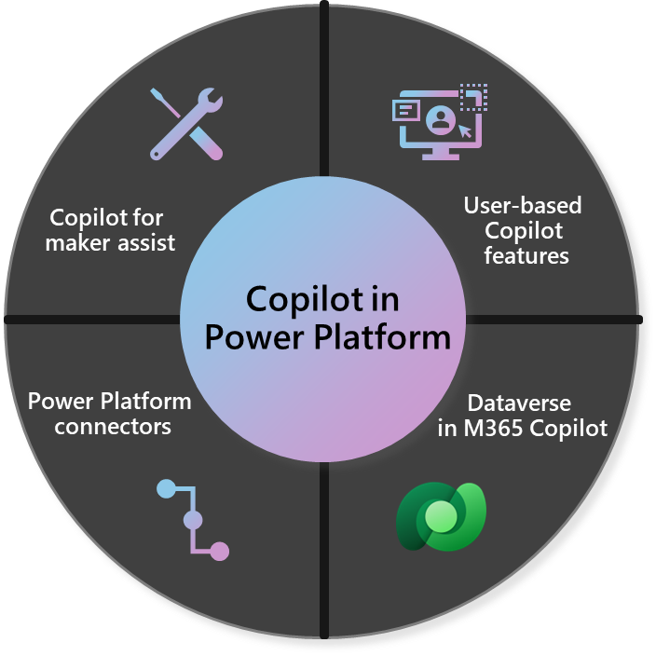

b

a

Industry clouds

Trusted

Microsoft

**Copilot for maker assist -** Copilot for Power Platform enables AI-assisted low-code development that uses natural language to create a first draft of the application solutions businesses need. It does not replace the critical thinking of professionals, but it makes them much more efficient.

**Power Apps Copilot for users -** Power Apps offers Copilot controls to include in custom Power Apps for the end-users in organizations interacting with the apps. Users can use natural language to explore data and navigate apps, significantly improving the user experience and generating new sources of business intelligence.

**Power Platform connectors as Copilot plug-ins –** Power Platform connectors can be used as plug-ins for Copilots, enabling them to infuse just-in-time information from the connectors for use by the Copilot. This can empower the Copilot to provide information and perform tasks beyond its basic capabilities.

**Access Dataverse data in Microsoft 365 Copilot –** Make Dataverse data available without the user leaving the Microsoft 365 application. This capability integrates data the user needs without requiring difficult data integration development efforts.

# Copilot for maker assist

Copilot for Power Platform offers several AI-assisted maker experiences. This category of Copilot is focused on making the people building solutions on Power Platform more productive and improving their overall experience. Copilots do this by assisting with mundane and repetitive tasks people building solutions have to do. Copilots can also help answer questions like “What does this formula do?” or “How do I do something?”. These Copilots are not static and will continue to evolve with each of the products they are embedded in to offer additional capabilities to assist users in building solutions.

Now, let’s dive a little deeper into how these Copilots are used in each Power Platform product.

## Copilot for Power Apps

Power Apps provides a rapid development environment for building custom apps. Apps built using Power Apps can use data and services from more than a thousand connectors. The apps can run on a browser, desktop, or mobile device. Copilot for Power Apps is all about helping to build apps. This starts with using natural language to describe the desired application. For example, a business needs to track internal support tickets. A user can describe what they are trying to build to Copilot. Then, Copilot takes that description and presents the user with a table that includes AI-generated sample data. Data can then be reviewed, edited, and approved before the first version of the canvas application is made. The users can make edits to this table definition, using the same natural language descriptions to have a multi-step interaction to refine how their apps work. Once confirmed, the canvas app is created. The app maker can then revise this app to make it exactly what they need.A screenshot of a computer

## Copilot for Power Automate

Power Automate is a powerful workflow automation that integrates with Power Platform and existing tools and platforms businesses use through a thousand published connectors. Power Automate is a low-code solution, allowing users and makers of all skill levels to automate tasks.

Copilot can also be used to automate tasks in cloud flows. For example, internal support ticket escalation notifications must be sent to managers. Using Power Automate, employees can use Copilot to build a cloud flow that automatically connects with Dataverse to gather ticket details, identifies the assigned user, identifies their manager, and crafts the notification to send. Whoever is developing the flow then reviews and adjusts the cloud flow steps to ensure that it meets the stated requirements given to Copilot.  
  
## Copilot for Power Pages

Power Pages enables the quick creation of secure, low-code business websites. Business teams, not just developers, can build these sites, resulting in a professional website that gets to market faster and at a lower cost.

Copilot for Power Pages helps site creators accelerate their efforts to build and maintain their websites, from common tasks like adding a page to more content-related actions like changing the content tone. For example, a creator might ask Copilot to make the content pasted from the old site more modern. Copilot would update the content and ask the creator to review and adjust if necessary.

Most websites capture some information from their visitors, and it is common with Power Pages to store that in Microsoft Dataverse. Creators can specify the type of form they want, and Copilot will autogenerate tables in Microsoft Dataverse and build the corresponding forms.

Power Pages also empowers site creators with the integration of Copilot chatbot activation. Seamlessly add a Power Virtual Agents chatbot with generative answers via a simplified experience within the setup workspace, streamlining the website management process. For website visitors, this feature enhances their interaction with the site, allowing them to ask natural language questions and receive concise responses with relevant information or links to optimize administrative functionality and website engagement experiences.

## Copilot for Power Virtual Agents

Power Virtual Agents provide a low-code experience to build intelligent bots that respond rapidly to customer and employee needs. Bots can be configured using the bot designer without knowing the details of the different channels and infrastructure the bot will be hosted. By configuring the various topics, the bot can respond to inbound interactions.

Copilot for Power Virtual Agents facilitates the creation of a bot by describing what the user would like the bot to do in natural language. Then, the bot can be adjusted and fine-tuned from testing and feedback. For example, an author can simply state: “Allow a user to start planning a trip, collect the user’s email address, and phone number, and let them choose the trip type from business, personal, or both,” and a dialog to do so will be instantly created including all the various components of the bot design. The author can then select part of what was generated and ask Copilot to refine it or, just like before, use the designer to adjust it just like they did before Copilot manually.

# Power Apps Copilot for users

When businesses implement the Copilot Stack AI framework, code developers can add in-app custom Copilot experiences to their applications built with traditional code. Similarly, anyone building a low-code application with Power Apps can include a pre-built Copilot control for a low-code experience to add a Copilot to their application. The application can provide an in-app Copilot experience, allowing users to interact with the data using natural language queries by configuring a view of a data source and some basic prompt information.

Users of the application can use Copilot to answer questions about the data in the application. The user would formulate their questions using natural language questions just like they might ask a co-worker if they were asking them to gather data for their question. For example, in an auto insurance application, the user might ask, *“What is the earliest date the car had insurance with the company?”.*

The example below showcases a Power App for banking—specifically, the user screen for working with support tickets. The user can ask the Copilot about the data. The user asks for information about high-priority tickets and follows up with an inquiry about the tickets from the last month. This helps the user quickly identify trends and prioritize resolving high-priority tickets. The Copilot control is included with the Power App and supports users within the application using the application’s data with natural language queries. By having this Copilot control, the development team can accelerate the development time without compromising the user needs of additional views, details, and interaction with the data.

Adding Copilot to low-code apps can make the applications more flexible to meet users' evolving needs. Instead of asking the maker to change the application, in many cases, users can simply ask the Copilot in the app the question about the data.

# Power Platform connectors as Copilot plug-ins

Power Platform connectors are also important to the Copilot experience. Users can connect Copilot plugins to extend the capabilities of Copilot. For example, Microsoft 365 Copilot with the Power Platform connector for Jira Software can enable a project manager to request the status of a Jira support ticket and act based on the response, such as route it for additional approval or start a purchase order for new hardware. Using plugins, you can integrate your business processes and data with Copilot to empower users to interact from whatever app they use.

# Access Dataverse data in Microsoft 365 Copilot

Traditionally, users waste a fair amount of time jumping from one application to another to obtain the answers they need to complete a task. Imagine a user in Microsoft Outlook who just received an email from a client urgently asking for the status of their equipment being serviced. Currently, they leave their email client, open the internal application, look up the customer, open and copy the status of each piece of equipment, and then return to the email and type a summary of the equipment being serviced. Instead, the Microsoft 365 Copilot will be able to incorporate your Power Platform data stored in Microsoft Dataverse. Users can use application data without having to switch back and forth between applications. For example, from within the email client, a user could ask the Copilot to generate a status update for all the equipment being serviced for the client. Microsoft 365 Copilot automatically inherits the native security and governance framework of Dataverse and applies user security and permissions at runtime.

# Embracing the next wave of AI Innovation

AI is changing how we all do business, and the timeline for these changes to occur is accelerating with each advance in AI capability. Accelerate Tech has the technical and industry expertise to support your business to keep up with these changes and realize business impacts faster. As a Microsoft partner, we can help you leverage the leading framework to approach AI responsibly and effectively. This effort includes a robust approach to incorporating AI responsibly into our organization's daily life. Copilots harness this power of AI and make it approachable to normal business users in the applications they use every day.

Power Platform's low-code capabilities implemented by a low-code integrator are a natural fit for helping organizations build AI solutions, with Copilot assisting. Using Power Platform Copilot capabilities, organizations can build solutions faster because users no longer need to spend time doing tasks that Copilot could do. With the change in capabilities of AI happening at an increasing pace, organizations need assistive technology that also evolves with the rate at which AI is changing. Copilots, by design, can incorporate emerging AI capabilities as they are released. The combination of Accelerate Tech, Power Platform, and Copilot offers organizations a chance to evolve with the rapid AI innovation happening across all industries and organizations.

Schedule a demo to learn more about how Accelerate Tech can help you unlock the benefits of AI-powered Copilots at our [website](https://acceleratetech.au/contact-us/).